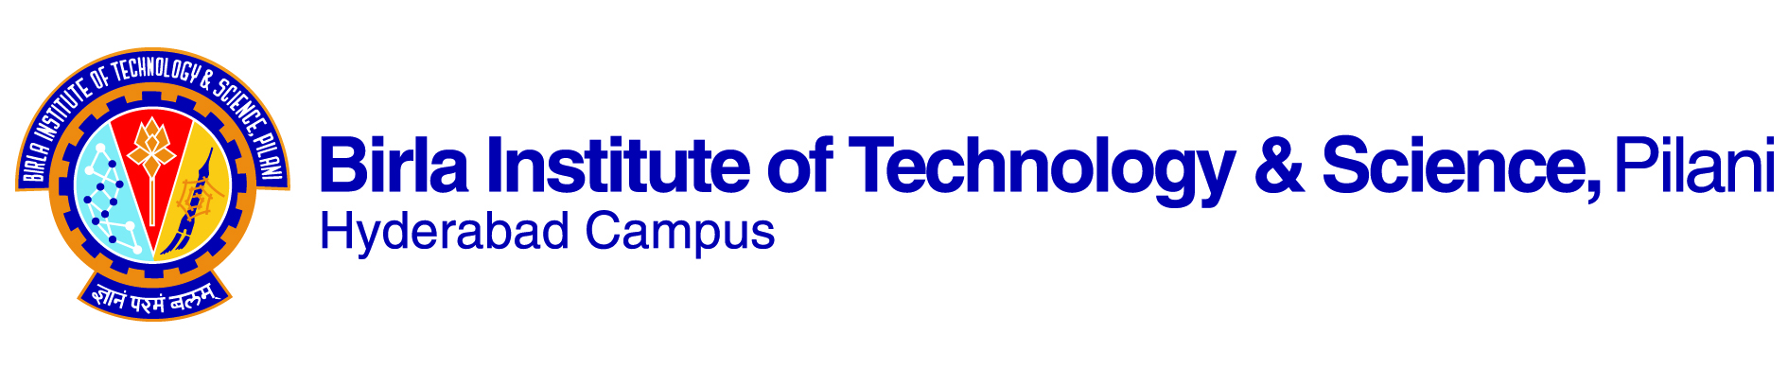

**SECOND SEMESTER, 2018-2019**

**COURSE HANDOUT (PART-II)**

07/01/2019

In addition to Part-I (General Handout for all courses appended to the time table), this portion gives further specific details regarding the course.

***Course Code*: ME/MF F342**

***Name of the Course*: Computer Aided Design**

***Instructor-In-Charge*: SRINIVASA PRAKASH REGALLA**

**I. Scope and Objective of the Course**

CAD software and CAD hardware. Mathematical modeling of parametric curves, surfaces and solids, and their computer simulation on spreadsheets and using specialized solid modeling packages. CAD/CAM data exchange. Introduction to finite element analysis and FEM practice on a specialized CAE package. Rapid prototyping. Students will be required to do several assignments and one CAD project.

# II. Textbook

1. Zeid , Ibrahim, “Mastering CAD/CAM”, Tata McGraw-Hill, 2007.

# III. Reference

1. Srinivasa Prakash Regalla, “Computer Aided Analysis and Design”, IK International Publishers, New Delhi, 2010.
2. Chandrupatla, T. R., Belegundu, A. D., “Introduction to Finite Elements in Engineering”, 3rd Edition, Prentice Hall of India, 2005, New Delhi.

**IV. Course Contents**

| S. No. | Learning Objectives | Learning Outcomes | No. of Lectures | Source |
| --- | --- | --- | --- | --- |
| **Computer Aided Geometric Modeling and Design** | | | | |
| 1 | CAD software and CAD hardware | Introduction, 3D modeling and viewing, modeling aids and tools, engineering drawings, CAD programming, Computer simulation tools, Primer on MATLAB | 4 | TB: Ch-1 to 4 |
| 2 | Parametric Curves: Mathematical modeling and computer simulation | Geometric Modeling: Curves, theory and MATLAB modeling | 4 | TB: Ch-6 |
| 3 | Parametric Surfaces: Mathematical modeling and computer simulation | Geometric Modeling: Surfaces and NURBS, theory and MATLAB modeling | 4 | TB: Ch-7 & 8 |
| 4 | Parametric Solids: Mathematical modeling and computer simulation | Geometric Modeling: Solids and Features, theory and Pro/E modeling | 3 | TB: Ch-9 |
| **Integration of CAD and CAE with CAM** | | | | |
| 5 | Introduction to FEM and practice: Modeling and analysis of solid mechanics and heat transfer problems using FEM packages | Fundamental concepts, matrix algebra and Gaussian elimination | 3 | TB: Ch-17 & RB1: Ch-11 &  RB2 |
| One-dimensional problems | 4 |
| Two-dimensional problems | 5 |
| Beams and frames and 3D problems | 3 |
| Scalar field problems and dynamic considerations | 5 |
| 6 | Introduction to Rapid Prototyping/Additive Manufacturing | Different RP/AM technologies, their Pro/Cons | 2 | RB1: Ch-17 |
| 7 | CAD/CAM Data Exchange | Data exchange neutral formats, 2-D and 3-D geometric transformations | 3 | TB: Ch-12 |
|  | Total |  | 40 |  |

**V. Evaluation Scheme and Schedule**

|  |  |  |  |
| --- | --- | --- | --- |
| Component | %Weightage (Marks)  (Total Marks=200) | Date | Type |
| Mid-semester Test | 25% (50 marks) | 13/3, 9-10.30 | CB |
| Practicals using COMSOL/Matlab/ANSYS | 15% (30 marks) | As per Timetable | D208:  CAD Lab |
| Tutorials | 15% (30 marks) | Friday, 8 AM | OB |
| Class Room Interaction Quiz (CRIZ) | 5% (10 marks) | Surprise | Using Google Classroom |
| Comprehensive Examination | 40% (80 marks) | 06/05/2019, FN | CB |

**VI. Chamber Consultation Hour:** It will be announced in the class.

**VII. Notices concerning the course:** All notices concerning the course are displayed on the Mechanical Engineering notice board and/or CMS only.

**VIII. Make-up Policy:** Make up for any component of evaluation will be permitted only in genuinely serious cases only after production of necessary medical certificates and with prior permission.

**XI. Academic Honesty and Integrity Policy:** Academic honesty and integrity are to be maintained by all the students throughout the semester and no type of academic dishonesty is acceptable.

Instructor-In-Charge